caElmir – UC, Davis

Software Design Description

Version 1.0

Document Change Record
Version Number | Date | Description | Author
1.0 | 07-Aug-06 | Initial Draft | Sumit Deshmukh

TABLE OF CONTENTS
1. Introduction 1
1.1 References 1
1.2 Definitions 1
1.3 Document Overview 1
2. SYSTEM DESIGN 2
2.1 System ARCHITECTURE 2
2.2 Object model 4
2.3 Data model 5
3. COMPONENTS 6
3.1 Basics of Java Struts 6
3.2 API Access 7
3.3 Data Access Layer 9
3.4 The caDSR/EVS Interface 11
3.5 csm interface 17
3.6 Audit Interface 22
3.7 Query Interface 24
3.8 The caDynamicExtentions 30
APPENDIX A – DOCUMENT TERMINOLOGIES AND ACRONYMS 31
APPENDIX B – CLASSES 32
HTTP API Access 32
Data Access object Interface 34
EVS/caDSR Interface 34
Audit Module 36
Query Interface 36

Introduction
This document describes the design of caElmir system. Design of the caElmir application is based on “Java Struts” framework. Interaction with the database is performed using either Hibernate or Java Database Connectivity (JDBC) based on performance requirements. This document describes the system architecture, detailed design of important objects/classes, and their interactions.
In order to understand the design completely, it is necessary to understand the basics of Java Struts framework. The reader can refer to Section 3.1 - BASICS OF JAVA STRUTS for a brief introduction to Java struts, or refer to Jakarta Struts for complete details.

References
- caElmir Use Case Document
- caElmir Software Requirement Specification (SRS)
- caElmir Object Model
- caElmir Test Approach Doc
- Jakarta Struts

Definitions
Field | Definition
Business Logic | Business logic is the component/code which implements functionality or business rules of a software application.
Model | Data representation of a system.
View | User Interface (UI) representation of a system.
Controller | Component of a system, which holds the business logic of the application and acts as a link between the Model and the View.
Data Source | Distinct pieces of information usually formatted in a special way.
Cache | A piece of data, which is used frequently in an application, is copied in primary memory of a local database in order to achieve high-speed execution of the application.
Factory | Factory is one of the creational patterns where an instance of one of several possible classes is returned based on the data provided.

Document Overview
This document captures design descriptions for the caElmir v1.0 project. The remaining design sections are organized as follows:
- SYSTEM : Describes the overall architecture of the system.
- COMPONENTS: Describes the various components/interfaces of caElmir. For example, DAO, EVS/caDSR interface, Query interface and so forth.
- APPENDIX A – DOCUMENT TERMINOLOGIES AND ACRONYMS: Various abbreviations and terminologies used in the document.
- APPENDIX B – CLASSES: Describes the crude definition of classes, their attributes and important methods.

SYSTEM DESIGN

System ARCHITECTURE
The caElmir application is comprised of an n-tiered architecture, as depicted in the following figure. The client layer contains applications on the client side that request to perform operations on the server side. The web browser and JAVA HTTP API are two of the client programs in caElmir. The presentation layer provides a web interface as well as support for the HTTP API. The object layer is the heart of the application, and contains domain objects, model classes and the data access layer. This is the place where all business requirements are fulfilled. The backend of the application is a local database that stores all the pre-clinical experimental information.

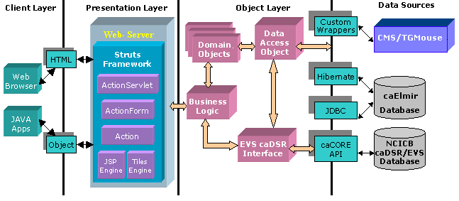

The main components of the application are as follows:
- Web interface: Web pages and HTTP APIs
- Business Logic
- Data access object
- External data sources interface
The web-based user interfaces are designed and developed in a Java/Struts framework. The design follows the Model View Controller (MVC) design approach wherein the view (i.e. the user interfaces) and the model (i.e. the actual application logic) are completely insulated.
The web interfaces communicate with caElmir database and external data sources like caDSR, EVS and Colony management System (CMS)/TgMouse Application through an intermediate interface. The intention of the interfaces is to insulate the core application logic from any changes in the external data source.
Internally the caElmir application is reusing existing components developed for “caTissue Core” application:
- API Access
- Data access layer
- The caDSR/EVS interface
- CSM interface
- Audit interface
- Query interface
Interaction with the database is performed using either Hibernate or JDBC based on performance requirements. Hibernate is used in cases where simple objects are to be inserted/updated in the database. In cases like query interface where high throughput queries can be expected, JDBC is used. The intent here is to extract the best of both worlds.

The following diagram outlines the high-level activity flow of an HTTP request:
The caElmir provides HTTP based JAVA APIs to enable programmers to access all functionalities that are also available through the web interface.
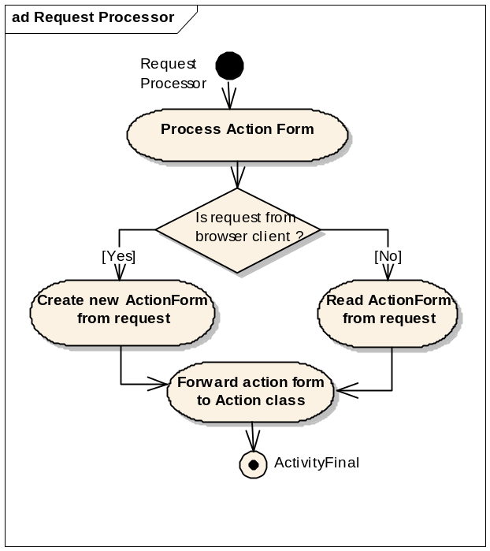
Internally, the design is such that the same code is used for both HTTP and browser access. To facilitate this, the application uses a customized RequestProcessor to differentiate between HTTP requests made through web browsers and JAVA clients.
The rest of the document assumes that the web interface is being used when describing the components. However, apart from the RequestProcessor, the rest of the application design/code is the same for both interfaces.

Object model
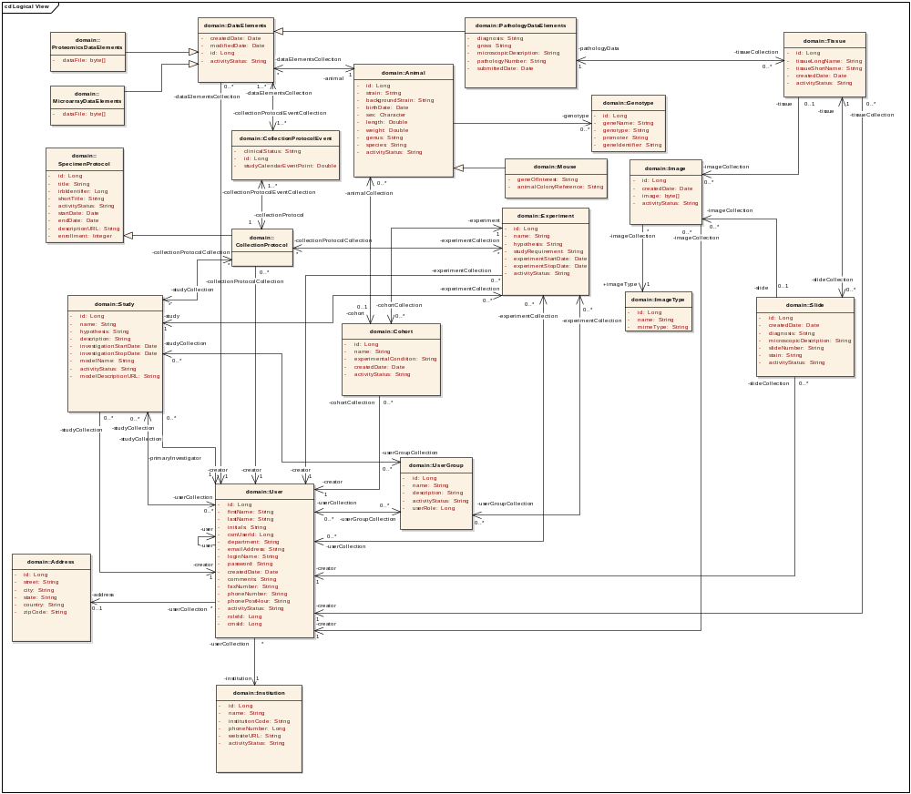
Domain Objects
Institution: This class contains the information related to an institution.
User: This class represents a person, who interacts with the caElmir system. The user can have multiple roles and based on his role gets privileges in the system.
UserGroup: This class represents the collection of users. The users with a common research objective are grouped together in the user groups. Primary investigator can associate the user groups to his study.
Address: This class represents the physical location of a User.
Study: This class represents a set of related experiments designed to collective test a common hypothesis.
Experiment: This class represents a testable assertion defined by a hypothesis.
Collection Protocol: This class represents a set of written procedures that describe how the data is collected in an experiment. It also defines the event points to collect data elements. (this class is reused from caTissueCore)
DataElement: This is a base class for other defined Data Elements. E.g. MicroarrayDataElement, ProteomicsDataElement and PathologyDataElement are derived from the base DataElement. The classes Case, Tissue, Slide and Image are the defined parameters of the PathologyDataElement.
StudyUser: This class contain the collection of users associated with the specific Study. This class can also store study based additional privileges assigned by PI.
Animal: This class represents a non-human living creature, which may serve as the subject of an experimental condition.
Cohort: This class represents a collection of animals within an experiment, which share a common experiential condition.

COMPONENTS

Basics of Java Struts
As mentioned above, caElmir is primarily a Java Struts framework based web application. This section briefly describes various facets of the Struts framework.
In a Java Struts framework, the typical flow of events is as follows:
- User enters the information into the web page.
- Upon submission, the action form containing the information is passed on to the action class.
- The action class performs the necessary validation and creates the domain objects.
- The domain objects are then passed on to the data access class which inserts the data into the database.
In the case of edit, the same flow of events is followed twice; once to get the data and again to submit the edited information.
The following sections introduce some of the basic components of Java Struts:
Action class
The action class is the link between the model and the view. The primary responsibility of this class is to:
- Retrieve the information from the web page (ActionForm object) and create the appropriate domain objects.
- Perform the action (e.g. searching the database based on an identifier).
- Return the results back to the web page.
Controller
The Controller component of the Struts Framework is the backbone of all Struts based applications. It is implemented using a Servlet named ActionServlet.
- This servlet receives all requests from the clients, and delegates the control of each request to a RequestProcessor class.
- The RequestProcessor processes each request by initializing the ActionForm associated with the web page and then delegates the control of the request to a user defined Action class.
ActionForm: The ActionForm object contains inputs supplied by the user. The RequestProcessor prepares an ActionForm object from an HttpRequest and forwards it to the action classes for validation of business requirements.
Domain Object: The domain objects are value objects of the application e.g. Participant, Accession, and Specimen etc. The domain objects are populated by the Action classes, and then passed to the Data Access Object class.

API Access
The main goal of caBIG is to create a network or grid of applications, shared data and tools, thereby creating a World Wide Web for cancer research. In order to achieve this, the caElmir application provides an Application Program Interface (API) so that others can access meaningful data and either correlate data with other applications or create new applications. The API also handles the directly associated object, as displayed in add/edit page of that object, while adding/editing the domain objects. For example, Adding or editing the Study information also adds or edits associated StudyExperiments in the system.
To provide this functionality the system uses java.net.URL, java.io.ObjectOutputStream and java.io.ObjectInputStream classes from JAVA API to communicate between client and server applications. The basic assumption is all the domain objects must be a java.io.Serializable objects. The basic flow of object communication between client and server application is as follows:
- Client Application
  - Establishes a connection to the server
  - Gets the output stream from this Connection object
  - Wraps the OutputStream to ObjectOutputStream
  - Writes data (domain Object) to the stream
  - Closes output stream
  - Waits for Response

- Server Application
  - Waits for any request for connection
  - Opens connection with the client application
  - Gets input stream from Connection object
  - Wraps InputStream to ObjectInputStream
  - Reads the domain object from the stream
  - Closes the input stream
  - Performs the specified operation
  - Opens the output stream from Connection object
  - Wraps OutputStream to ObjectOutputStream
  - Writes the resultant object to output stream
  - Closes the output stream

- Client Application
  - Opens input stream from the server
  - Wraps InputStream to ObjectInputStream
  - Reads the resultant objects from input stream
  - Closes the stream
  - Closes the connection

caHTTPClient: caHttpClient is a common wrapper class over HTTP APIs that provides APIs to connect and accesses the caElmir Application through the JAVA applications.
To use a caElmir API through JAVA applications, the class provides following two methods:
- connect:
- This method connects to the server and authenticates the user.
- After successful authentication of the user, the server sends a session id to the client.
- The caHttpClient class stores the session id for subsequent use.
- doOperation: This method performs the specified action on a given form object. The user creates a new instance of the desired ActionForm object and passes this object and action name to this method.
The method then performs the following steps:
- Sends previously stored session id and Domain Object to the server.
- On successful completion of the operation it returns a success object results.
- In case of error it throws an exception.
Class Structure: HTTP API Access

Data Access Layer
The data access layer follows the Data Access Object design pattern and is the interface between the caElmir database and the application. It contains generic APIs to perform basic database operations like read, insert, etc.
This implementation allows us to:
- Separate the client interface (presentation layer) and business logic from the data access mechanisms.
- Encapsulate the data source such that data-accessing the API remains standard regardless of the access methodology used. E.g. JDBC /Hibernate.

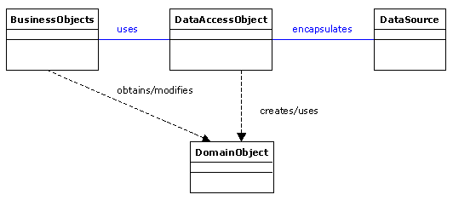
The Data Access Layer is designed to be a Java Interface with Hibernate and JDBC specific classes implementing the interface. This design provides the flexibility of easily interchanging the interfaces based on performance requirements.
Architecture Diagram: 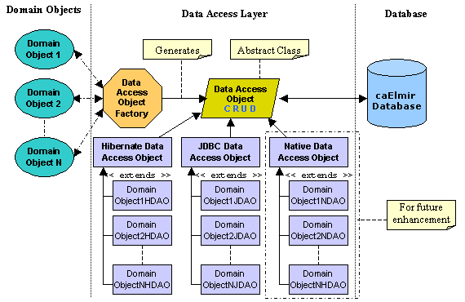
The following are major components of the Data Access Object layer.
Data Access Object: This is an abstract class, which acts as an interface between the application layer and the data layer. This class provides all the basic methods which are used for interacting with the underlying database, e.g. create, retrieve, update and delete. This follows a simple J2EE CRUD design pattern. The significance of this class is that, the whole application is unaware of the actual implementation of the data access mechanisms. HibernateDAO and JDBCDAO are the two concrete classes that provide implementation for the method defined by this class.
Data Access Object Factory: This is based on the factory design pattern.
Class Design
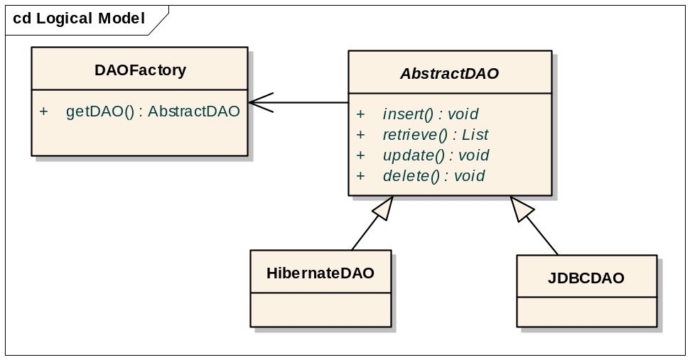
Class Structure: Data Access object Interface

The caDSR/EVS Interface

Problem Context
caDSR and EVS are the two external databases the caElmir application will be retrieving data from. These databases are accessed using the caCORE APIs.
The caDSR database contains information about CDEs and their permissible values (PV). In most of the cases, the permissible values are terms in the EVS database. However, the following issues were encountered when we examined the caDSR and EVS:

Problem | Resolution
Some CDEs are defined properly but the PVs are insufficient. | Permanent: Curate the value domain  Temporary: Have the ability to configure caElmir to consider additional terms as additional PVs.
In some cases, the PV has child terms in the EVS hierarchy. E.g. kidney is a PV for the CDE Tissue_Site. EVS has the terms right and left as child terms for the term kidney. We expect that even left kidney and right kidney should be available as PV for Tissue_Site in the caDSR. | Permanent: Discuss with EVS team  Temporary: Have the ability to configure caElmir to consider hierarchy in EVS as additional PVs.
Time taken to retrieve data is very high. | Cache data locally.

Considering the above-mentioned issues, we have defined an XML based configuration file, which allows customizing the interaction with the caDSR and EVS. If and when the curation of CDEs is complete, the configuration file can be easily modified to read all values from the caDSR.
One important point to note here is that the property file will be present outside the executable and thus it will be available at individual installation sites for configuration. This will help in setting up CDEs and associated permissible values for each caElmir installation at different institutes.

Design
The caDSR/EVS interface is designed as a generic solution to be used by any application that frequently interacts with the caDSR. It describes a technique that all applications can use to cache CDEs locally. Here, the caElmir application is used as a model application to describe the design and use of the interface.
The caDSR/EVS interface is designed with the following goals:
- Insulate the rest of the application’s code from the caCORE APIs.
- Enable caching (in-memory or/and disk).
- Provision for retrieving CDEs directly from the caDSR.
The user has to configure the CDEs to be retrieved along with the following properties in an XML based configuration file:
- Whether to cache CDEs in a local database or retrieve them from the caDSR each time.
- Whether to retrieve the EVS tree hierarchy for each permissible value.
- Configure additional permissible values.
- Local database cache refresh rate.

The XML based properties file structure for configuring CDEs is as follows:
<XMLCDE_CACHE refreshTime="TIME" lazyLoading="BOOLEAN">
<XMLCDE cache="BOOLEAN" lazyLoading="BOOLEAN">
<name>Name of the CDE</name>
<publicId>Unique caDSR ID for the CDE </publicId>
<XMLPermissibleValues>
<evsTerminology>TERMINOLOGY_DB_NAME</evsTerminology>
<conceptCode> CONCEPT_CODE_#1 </conceptCode>
<parentConceptCode></parentConceptCode>
<depthOfHierarchyTree> NUMBER: DEPTH OF HIERARCHY TREE </depthOfHierarchyTree>
</XMLPermissibleValues>
. . .
<XMLPermissibleValues>
<evsTerminology>TERMINOLOGY_DB_NAME</evsTerminology>
<conceptCode> CONCEPT_CODE_#N </conceptCode>
<parentConceptCode> PARENT OF THIS PERMISSIBLE VALUE</parentConceptCode>
<depthOfHierarchyTree> NUMBER: DEPTH OF HIERARCHY TREE </depthOfHierarchyTree>
</XMLPermissibleValues>
</XMLCDE>
</XMLCDE_CACHE>

XML-schema to define the XML cached properties file is as follows:
<xsd:schema xmlns:xsd="http://www.w3.org/2001/XMLSchema">
<xsd:element name="XMLCDE_CACHE" type="XMLCDECacheType"/>
<xsd:complexType name="XMLCDECacheType">
<xsd:sequence>
<xsd:element name="XMLCDE" type="XMLCDE" minOccurs="1" maxOccurs="unbounded"/>
</xsd:sequence>
<xsd:attribute name="refreshTime" type="xsd:int"/>
<xsd:attribute name="lazyLoading" type="xsd:boolean"/>
</xsd:complexType>

<xsd:complexType name="XMLCDE">
<xsd:sequence>
<xsd:element name="name" type="xsd:string"/>
<xsd:element name="publicId" type="xsd:string"/>
<xsd:element name="XMLPermissibleValues" type="XMLPermissibleValueType" minOccurs="1" maxOccurs="unbounded"/>
</xsd:sequence>
<xsd:attribute name="cache" type="xsd:boolean"/>
<xsd:attribute name="lazyLoading" type="xsd:boolean"/>
</xsd:complexType>

<xsd:complexType name="XMLPermissibleValueType">
<xsd:sequence>
<xsd:element name="evsTerminology" type="xsd:string"/>
<xsd:element name="conceptCode" type="xsd:string"/>
<xsd:element name="parentConceptCode" type="xsd:string"/>
<xsd:element name="depthOfHierarchyTree" type="xsd:int"/>
</xsd:sequence>
</xsd:complexType>
</xsd:schema>

Term | Definition
XMLCDE_CACHE | Root node of the configuration file. It lists all the CDEs that are to be used in the application.
refreshTime | Time duration in days. This specifies the number of days after which the cached CDEs should be automatically refreshed. The value can be also be expressed in floating point number E.g. to specify the refresh time as half day, the value should be set as “0.5”
lazyLoading | Boolean  This is used for two purposes:  - Application level  - If TRUE, retrieves CDEs only when requested by the application.  - If FALSE, retrieves all CDEs from the local database at application startup time.  - CDE level  - If TRUE, retrieves CDEs only when requested by the application.  - If FALSE, retrieves all CDEs from the local database at application startup time.  NOTE: When set at the application level, the parameter should be read and the appropriate method for the CDE Interface should be called by the application.
XMLCDE | This node describes every CDE associated with the application.
cache | Boolean  If TRUE, caches the CDE in the local database.  If FALSE, retrieves the CDE each time a request is submitted through the application.
name | Name the application uses to identify the CDE.  Note: This does not have to be the “public name” for the CDE in the caDSR.
publicId | Unique public ID for the CDE in the caDSR.
XMLPermissibleValues | This node describes every permissible value associated with a CDE.
evsTerminology | Name of the biomedical terminology database from which to retrieve the permissible value’s EVS concept. E.g. NCI_Thesaurus, GO, SNOMED_CT etc.
conceptCode | EVS concept code for the permissible value.
parentConceptCode | EVS concept code for its parent permissible value.
depthOfHierarchyTree | The depth of the EVS hierarchy up to which should be considered as permissible value for the CDE.

The following diagram outlines the high-level activity flow:
ad Activity Diagram
Retrieve CDE from caDSR
Has more CDEs ?
Read caching parameters, and list
the CDE to be cached
Retrieve CDE and permissible
values from caDSR
Use EVS Hierarchy
Tree ?
Retrieve sub concepts of
permissible values
Populate the
cache database
Modify timestamp
of last caching
Load the in-memory cache
Final
[No]
[No]
[Yes]
[Yes]
Block Diagram:
The following block diagram outlines the control flow among different classes of the caDSR/EVS interface.

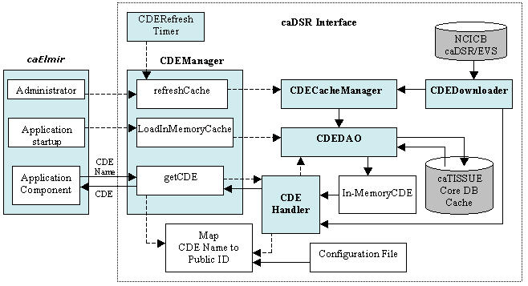

Major components of the common caDSR interface are as follows:
CDEManager: This is a communication link between the caElmir application and the caDSR interface.
CDECacheManager: This class retrieves live CDEs from the caDSR and updates the local database cache.
CDEDownloader: This is the class which actually communicates with the caDSR and EVS databases. It provides APIs to connect to the caDSR and EVS servers at NCICB using the caCORE 3.0 API and downloads the CDEs and associated EVS concepts.
CDEDAO: This is a DAO class for CDEs. Responsible for inserting/retrieving CDEs to and from the local database cache.
CDEHandler: This is a handler class that is responsible for returning a CDE either from in-memory cached CDE or directly from the caDSR based on the configuration.
CDERefreshTimer: This class invokes the refresh method of CDEManager at configured time intervals.

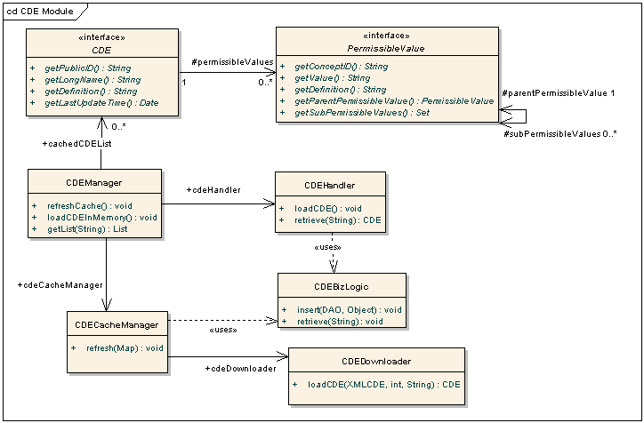
Class design
Interface structure of in-memory cache is as follows:
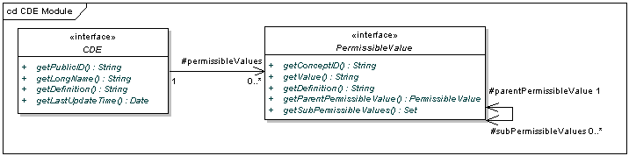
Note: The reason for using interfaces instead of classes is that the caller method/class can only retrieve data from cache and should not be able to update it. Classes CDEImpl, PermissibleValueImpl and EVSConceptImpl are a concrete implementation of the above interfaces, which also contains the set methods for cached data. CDE and PermissibleValue are interfaces and CDEImpl and PermissibleValueImpl are the implementing classes for these interfaces. These interfaces are exposed to rest of the application to access the CDEs and their permissible values via the getter method whereas only CDECacheManager is able to call the setter methods. This design helps in preventing any accidental call of the setter methods.
Database cache schema
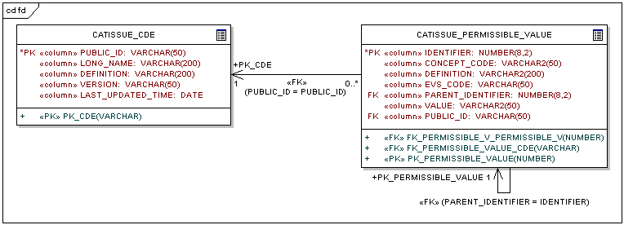

Class Structure: EVS/caDSR Interface

Note: caElmir is using this component as it is, hence the name of the tables are starting with “CATISSUE_”

csm interface
The caElmir system consists of Administrative data as well as pre-clinical experimental data. Data can further be classified as Identified / deidentified data. Users can be of different roles like Administrator, Primary Investigator, Experiment Creator, Data Creators and Public etc. They may have different kinds of privileges like READ, CREATE, UPDATE, EXECUTE & USE, etc on different data/actions depending on their role. They might also want to grant/revoke privileges on the data they own to some other users. The User Provisioning Tool (UPT) is part of the overall Common Security Module (CSM) developed for NCICB and is a web application used to configure caElmir’s authorization data. The UPT provides functionality to create authorization data elements like Roles, Privileges, Protection Elements, Users, etc., and also provides functionality to associate them with each other. The runtime API can then use this authorization data to authorize user actions.
Design
The CSM Interface encapsulates the CSM APIs in order to provide a generic security module for authentication and authorization. For every action the user tries to perform, he/she needs to be authorized by this module. The Struts actions and/or the DAO classes can access this layer.

In most cases, the action classes will interact with this layer to confirm whether the given user has permissions on the given object type; the DAO will interact with this layer to confirm whether the given user has permissions on the actual record. For example, if a user does not have privilege on an Experiment object, then the Struts layer will detect this; if a user does not have privilege on a specific Experiment record, then the DAO layer will detect it.
Struts Actions

- caElmir -
Security Manager
Application Layer
Authentication, authorization
Common
SECURITY
MODULE
(CSM)
Database Later
Basic workflow events to configure security needs of the application prior to running the application are as follows:
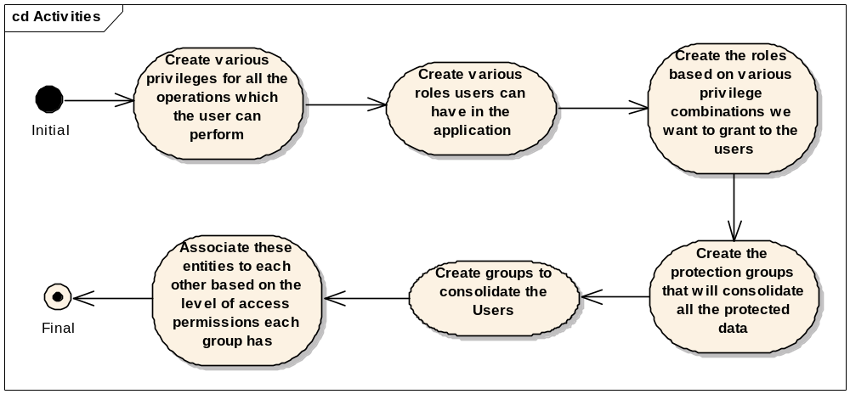
The diagram below represents the basic flow of events that take place when a new user is added to the runtime application.
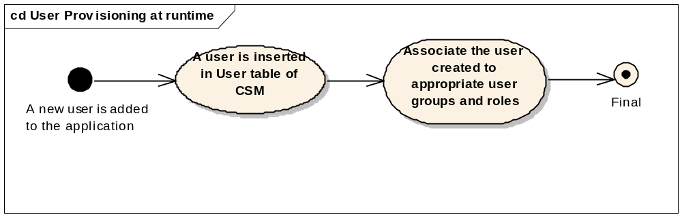
The diagram below represents the basic flow of events that take place when a new object is added to the application at runtime. 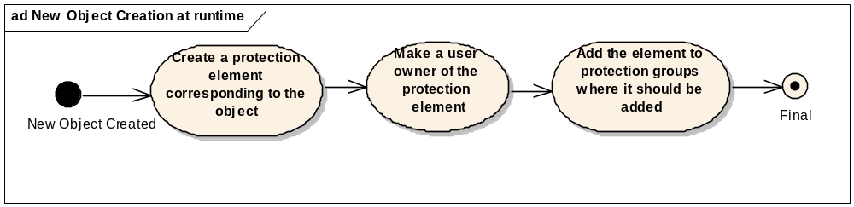
Roles and Privileges
Since privileges are associated only with roles, then roles also define a set of privileges that can be assigned to users or user groups. In addition to the various user roles, roles based on privilege combination can be granted. For example READ_ONLY_ROLE, UPDATE_ONLY_ROLE, READ_UPDATE_ROLE should be created if we want to grant read only, update only or read and update privileges to users.

Granting privileges

Any user should be able to grant privileges on the data they own to some other user. This could be at various levels, i.e.
  - Object level: A user can grant privilege to another user in order to access all data of a particular object.
E.g. User X gives READ privilege to user Y on the Study object he owns.
  - Record level: A user can grant privilege to another user in order to access a subset of the data of a particular object.
E.g. User X gives CREATE_EXPERIMENT privilege to user Y on the Study object.

Users will be able to grant/revoke privileges on the data they own to some other user/group through a grant/revoke privileges page.

Using CSM for granting specific object level privileges (not dependent on users’ system-wide role) on specific objects to specific users (Example considered here is of granting READ/ASSIGN_READ privileges on Collection Protocol and its related data to its PI and coordinators).

- First create various privileges for all the operations which the user can perform e.g. READ, ASSIGN_READ, CREATE, UPDATE, DELETE etc.
- Now create the roles based on various privilege combinations we want to grant to the users. E.g. READ_ONLY_ROLE (containing only READ Privilege), PI_-_ROLE (containing READ and ASSIGN_READ privileges)
- Step #2 can be performed in advance prior to the application running through the UPT.
- Now at run time let's say some ‘Study’ is created in the caElmir system and a user of the system is Primary Investigator (PI) of this ‘Study’ while some other users are Users/Students for this Study
  - A protection element corresponding to this Study is created.
  - A protection group by the name STUDY_<<STUDY_ID>> is created.
  - Protection element created in the first step is associated with the protection group above using the CSM APIs.
  - A group by the name PI_STUDY_<<STUDY_ID>> is created.
  - User who is the PI is associated with the above group using the CSM APIs.
  - Another group by the name USER_STUDY_<<STUDY_ID>> is created.
  - All users of the study (Experiment creators, Data Creators, etc) are associated with the above group using CSM APIs
  - PI_STUDY_<<STUDY_ID>> group and STUDY_<< STUDY_ID>> protection group are associated with each other through PI_ROLE.
  - USER_STUDY_<<STUDY_ID>> group and STUDY_<<STUDY_ID>> protection group are associated with each other through READ_ONLY_ROLE.
- If at runtime some more data related to this Study is created (example if a user is added to this Study or some Experiment is created for this Study)
  - A protection element is created for all the data that gets created
  - This protection element is linked to the same protection group STUDY_<<STUDY_ID>> that got created when Study got created.
- Thus, PI and other users of a Study get “READ” privilege over all the data that is related to this Study and PI gets additional privilege to assign read over this data to other scientists or students.
Percolating grants to related data
As explained earlier, data in caElmir is modeled in a hierarchical fashion Hence, when a user grants a privilege on a particular object, the user should also decide whether to extend that grant to all data in that hierarchy. E.g. If a PI grants READ privilege on a particular protocol, then he should also decide whether that grant applies to all the studies associated with that protocol.
This also applies to non-hierarchical data, but related data. E.g. An installation where a single caElmir serves multiple institutions, the administrator might want to restrict access based on which institute the user belongs to. Even though the Institute object is not in the data hierarchy, this grant has to be carried across all objects that belong to an institute.
Using CSM for granting privileges to other users on hierarchical and related data (Example considered here is of a PI assigning ADD_DATA privilege to some other users or groups for data that is related to the Study of the PI)
- Suppose the hierarchy of data is as follows:
STUDY → EXPERIMENT_COLLECTION → EXPERIMENT→ EXPERIMENTAL_DATA
- Now at run time let's say some clinician registers a PROTOCOL.
- The PI of this protocol is assigned READ and ASSIGN_READ privileges for the protocol as well as all data (participant registration, specimen collections, specimens and etc.) associated with the protocol as explained in the previous example.
- Assume that the PI wants to grant READ privilege to some other user/user group on either a particular data element or a data element as well as its children. To achieve this:
  - caElmir will create a protection group PG_<<USER_ID/GROUP_ID>>_ROLE_<<ROLE_ID>> if one does not exist.
  - Now add the protection elements which correspond to all the data elements he/she wants to grant privilege to as well as the related data elements to the above protection group. When a new related object is added to the system, it will also be the added to this protection group.
  - Associate the protection group with the user or user group the PI wants to grant privilege to through the READ_ONLY_ROLE if the association is not already present.
- This way the PI can grant privileges to other users for an object as well as its children.

Class design
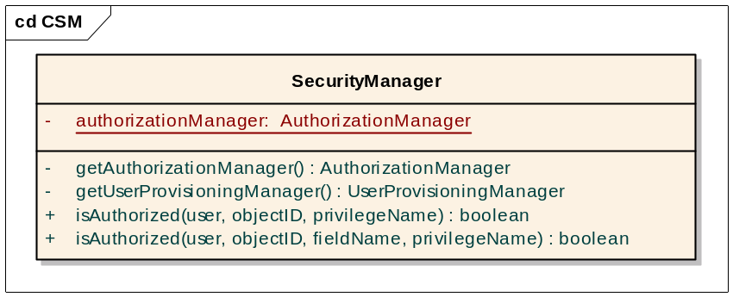

Audit Interface
This is a generic audit module to keep track of all database level change/events made by the application. For every data change, the system captures the event and stores a change log record in a separate audit table.
The audit table contains the following information:
- User who performed the action
- Timestamp of action
- Object and data element names (i.e. table name and column name)
- Previous value and new value of the data element
The audit table contains one entry per data element that has changed. In cases like edit or disable, there might be more than one entry in the audit tables per user action. For example, user updates more than one data element in one edit action.

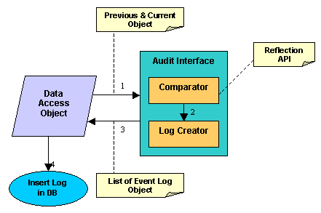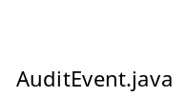

The above diagram depicts the four steps for recording an event in the Audit module.
- The Data Access Object layer calls the Audit Interface after any of the data manipulation operations on the databases e.g. Insert, Update.
- In the case of update, it passes the current object and previous object to the Audit interface.
- The comparator component of the Audit interface compares each attribute of these two objects with the help of a Reflection API, and creates an AuditEventLog object for each change. The AuditEventLog object contains following fields:
  - Object Identifier
  - Object Name
  - Event Type: Add, Update
  - Collection of AuditEventDetails
Each AuditEventDetails contains following fields
- Name of the attribute
- Previous value of the attribute
- New value of the attribute
- Once the Audit Manager completes the comparing all attributes of the object, it creates a list of EventLog objects and returns the list to the Data Access Object.
- The Data Access Object then inserts these values into the database.

Class Design
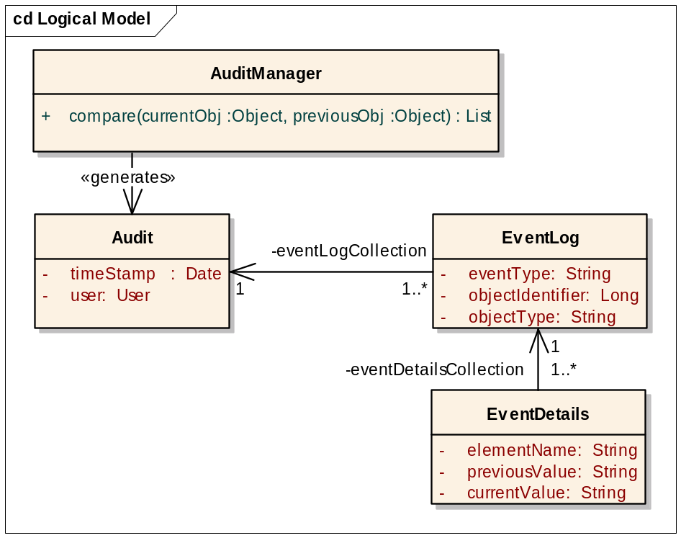
Class Structure: Audit Module

Query Interface
The caElmir system is using the common simple query interface, which can add conditions by selecting any data element. It is ideal for simple queries like “all Experimental data of a particular study”

The following diagram outlines the control flow for this interface:
Form Query
Form Query
Retrieve Saved
Query
Enter Query
Parameters
Submit Query
Generate Query
String
Execute Query
generated
Display
Results
End
Save Query
Define View
View Data
Remove data
user does not
have privilege to
see

The query interface is responsible for the following tasks:
- Enter query parameters: (essentially the WHERE part of the query)
- User enters rules for the query
- Application populates the in-memory data structures as rules are entered.
- Define view: (essentially the SELECT part of the query)
- User selects the data elements to be displayed.
- Generate query
- User clicks the Submit Query button.
- Application will traverse the conditions tree and create the SQL query.
- Query execution
- The query SQL is now executed and the results are stored in a temporary database table.
- Remove data user does not have READ privilege on
- Before the data gets displayed it is filtered to remove the data on which user does not have READ privilege.
- Display results
- Every time the user clicks on a particular node, the corresponding data from the temporary table is retrieved.
- If a user requests all information about an object, the corresponding object table is read for that object.

Design
To understand the design, the reader needs to understand the following issues:
- The design mainly revolves around abstracting the common functionality of simple and advanced query interfaces into the base classes.
- The advanced query has a hierarchy structure of conditions and hence the data is stored in a tree data structure.
- The simple query interface has a simple, flat structure of conditions and hence the data is stored in an array-like data structure.
The following class diagram outlines main classes of the query interface:
cd bean
Query
-
resultView: Vector<DataElements>
-
whereConditions: ConditionsImpl
+
execute() : boolean
+
addElementToView() : boolean
+
getString() : String
QueryFactory
+
newQuery() : Query
+
retrieveSavedQuery() : Query
+
saveQuery() : boolean
SimpleQuery
+
addCondition() : boolean
AdvancedQuery
+
addCondition() : boolean
ResultData
-
tmpResultsTableName: String
+
getTreeViewData() : DefaultMutableTreeNode
+
getObjectDetails() : Object
+
getSpreadsheetViewData() : Vector
+
saveToFile() : void
QueryFactory classes
- The factory class for Query objects.
- The QueryFactory class takes care of serializing, restoring and creating new Query objects.
Query Classes
- The model class for the query interface.
- The Query class is an abstract class which is further implemented by the SimpleQuery and AdvancedQuery.
- This class implements the JAVA Serializable class. This is done so that the Query object can be saved and restored, as explained in detail later.
- It contains the member variables for the results view and the conditions.
- Once the user submits the query, this class creates and executes the SQL query.
ResultData Class
- The model class for results view functionality.
- Takes care of data for the tree view, spreadsheet view, and single object details.
- Provides functionality to save data to file.

The condition objects are the base data structures that contain information about the conditions configured by the user. The following diagram outlines the implementation of the conditions classes.
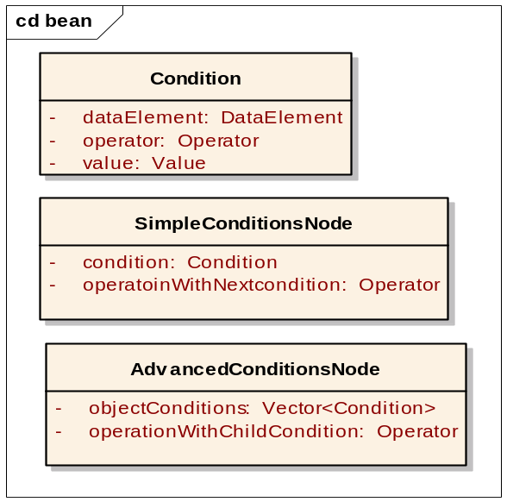
Condition
- The Condition class is the base data structure for a condition on a data element.
SimpleConditionsNode
- A node consists of a condition object and an operation with the next node.
- The operation with the next node is either AND or OR
- NOTE: AND operation has precedence over OR operation in the final formed query.
AdvancedCondtionsNode
- All conditions in a node are of the same type.
- AND operation is always performed among conditions in a node.
- The user can configure the operation to be performed with the children node.

The ConditionsImpl class is the model class for the conditions data structure. The derived classes, SimpleConditionsImpl and AdvancedConditionsImpl specialize the abstract base class.

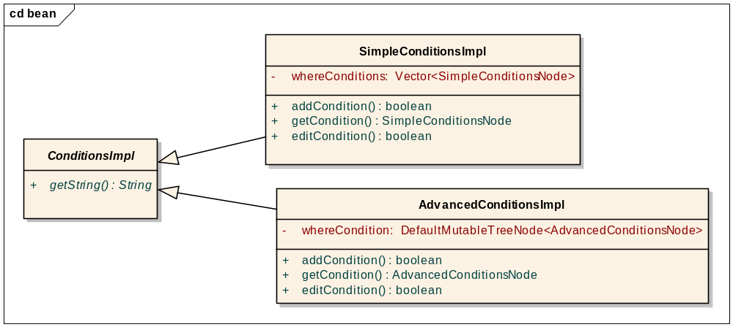

Sequence Diagram
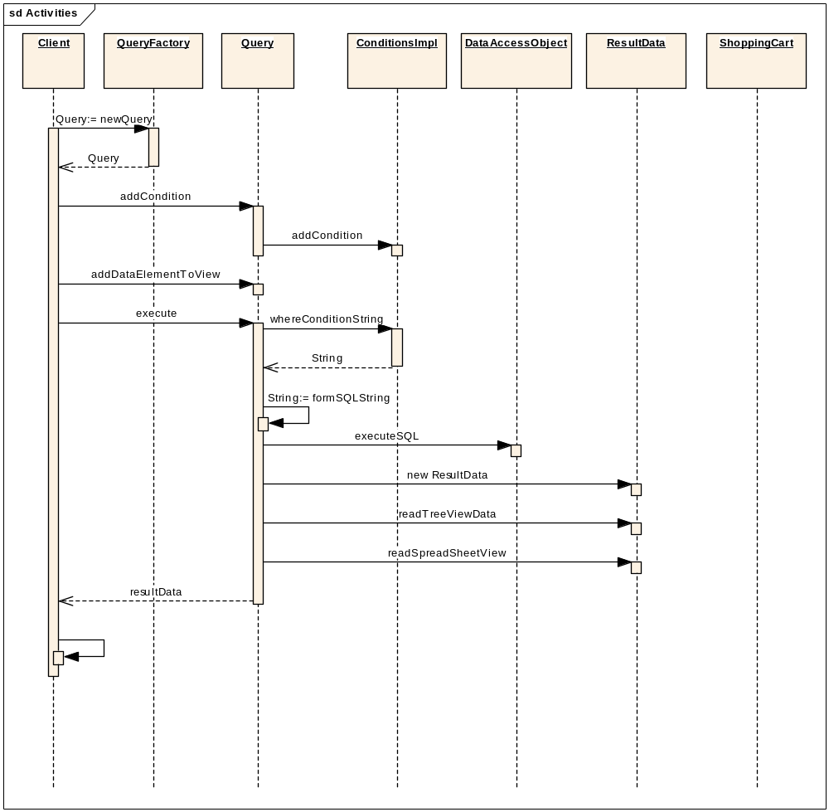
Once ResultData is returned, user is moved to the results view page.

Simple query interface
This query interface is a simple, flat structured interface wherein users can query on any data element. The concept and to some extent the user interface is based on the Bugzilla tool’s query interface. This interface is useful when the query is based on fewer parameters. For example, show all Users where FirstName starts with ‘Jose’.
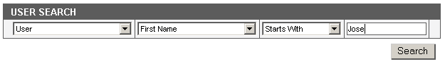
SimpleQuery is the model class that implements the following:
- Add/edit conditions using the SimpleConditionsImpl class.
- The base class handles the define view data structure.
- Once a user submits the query, an SQL string is generated and executed.

The Dynamic Extentions
TBD

APPENDIX A – DOCUMENT TERMINOLOGIES AND ACRONYMS
Acronym | Description
API | Application Programming Interface
caDSR | Cancer Data Standards Repository
CDE | Common Data Element
DAO | Data Access Object
EVS | Enterprise Vocabulary System
HTTP | Hyper Text Transfer Protocol
JDBC | Java Database Connectivity
MVC | Model View Controller
PV | Permissible Value
SRS | Software Requirement Specification
UI | User Interface

APPENDIX B – CLASSES

HTTP API Access
/** The RequestProcessor class contains logic that the Struts controller performs with each request from the Servlet container. caElmir uses customized RequestProcessor which extends the functionality of the default RequestProcessor by overriding the processActionForm method. */
class ApplicationRequestProcessor extends RequestProcessor
{
/* Overrides the processActionForm methods and return the ActionForm associated with this current action mapping. If the request is from the web browser it prepares the ActionForm from the request otherwise it reads the ActionForm from the request’s input stream and returns it for further processing */
protected ActionForm processActionForm (HttpServletRequest request,
HttpServletResponse response, ActionMapping mapping)
{
IF(request from web-interface )
Create new ActionForm from request parameter
Else
Read the domain object the client’s request.
Create the action form
}
}
/* Wrapper class provides API to connect and access application */
public class caHTTPClient
{
Stirng HTTPSessionID = null;

/* Connects to the caElmir application and authenticates the user. User needs to connect and authenticate himself/herself before performing any operation on caElmir. */
public boolean connect(String userName, String password) throws Exception
{
//Opens a connection to the specific URL
URL url = new URL(servletURL);
URLConnection con = url.openConnection();

Login login = new Login(userName,password);

ObjectOutputStream objectOutStream = getObjectOutputStream(con);
objectOutStream.writeObject(form);
objectOutStream.close();

ObjectInputStream objectInStream = get ObjectInputStream(con);

HTTPMessage responseObject = (HTTPMessage)objectInStream.readObject();
objectInStream.close();

if (HTTPMessage is SUCCESS)
{
HTTPSessionID = HTTPMessage.getSessionID();
return true;
}
return false;
}

/* Request the caElmir Application to perform the specified action on a given object. */
public Object doOperation(String actionName, AbstractDomainObject
domainObject) throws HTTPAPIException
{
String servletURL = createURL(actionName);

//Opens a connection to the specific URL
URL url = new URL(servletURL);

//use the post method to send the data
URLConnection con = url.openConnection();

//Server differentiate browser and HTTP API calls by the its CONTENT_TYPE
con.setRequestProperty(Constants.CONTENT_TYPE,Constants.HTTP_API);
ObjectOutputStream objectOutStream = getObjectOutputStream(con);

objectOutStream.writeObject(HTTPSessionID);
objectOutStream.writeObject(domainObject);
objectOutStream.close();

ObjectInputStream objectInStream = getObjectInputStream(con);
HTTPMessage responseObject = (HTTPMessage)objectInStream.readObject();
objectInStream.close();

if (HTTPMessage is ERROR)
{
throw new HTTPAPIException(responseObject.getMessage());
}
return responseObject;
}
}

Sample code that demonstrate the use the HTTP API is as follows
class SampleApplication
{
Public static void main(String []args)
{
Participant participant = new Participant();
Participant.setFirstName("Juli");
Participant.setLastName("Kate");
Participant.setGender("Female");
Participant.setRace("Unknown");

HTTPClient client = HTTPClient.getInstance();
boolean isConnOK = client.connect("admin@admin.com","login123");
if(isConnOK)
{
try
{
MessageObject message = client.doOperation(
HTTPClient.PARTICIPANT_ADD_ACTION,
participant);
System.out.println("Success Message "+ message.getContents());
}
catch(Exception ex)
{
ex.printStackTrace();
System.out.println("Error Message "+ ex.getMessage());
}
}
}
}

Data Access object Interface
/** This is an abstract class which acts as an interface between the application layer and the data layer. This class provides all the basic methods that are used for interacting with the underlying database, e.g. create, retrieve, update and delete. */
abstract class AbstractDAO
{
/*Insert the Object into the database. */
abstract insert (Object)

/* Retrieve and return the list of all source objects that satisfy the
given conditions on various columns. */
abstract List retrieve (String sourceObjectName, String whereColumnName,
String whereColumnCondition[], Object whereColumnValue[] ,
String columnOperator)

/* Updates the state of objects in the database. */
abstract update (Object)

/* Deletes the specified object from the database. */
abstract delete(Object)
}

EVS/caDSR Interface
CDEManager:
/** This is a communication link between the caElmir Application and the caDSR interface. */
class CDEManager
{
/** Retrieves live CDEs from the caDSR and updates the database cache. */
public void refreshCache()
{
CDECacheManager.refresh();
}

/* Populates the “in-memory cache” from the “database cache”. The loading operation will be performed at application startup time. For faster startup time of the application, all CDE’s can be configured for lazy loading at the application level as well as individual CDE level. In lazy loading, required CDE’s will be loaded in-memory during the first call to that CDE. */
public void loadCDEInMemory()
{
CDEDAO.retrieve();
}

/** Returns CDE for given CDE Name. */
public CDE getCDE(CDE_Name)
{
CDEHandler.retrieve(CDE_Name);
}
}

CDEDownloader
/** This is the class which actually communicates with the caDSR and EVS databases. It provides APIs to connect to the caDSR and EVS servers at NCICB using caCORE3.0 API and downloads the CDEs and associated EVS concepts. */
class CDEDownloader
{
/** Loads the latest version of the Data Elements using the caDSR JAVA API for a given public ID. */
CDE loadCDE(CDEPublicID)
}

CDEDAO:
/** This is a DAO class for CDEs. This is responsible for inserting/retrieving the CDEs to/from local database cache. */
Class CDEDAO extends AbstractDAO
{
/* Loads the Data Elements from the database cache for a given public ID.*/
CDE retrieve(CDEPublicID)
}

CDEHandler:

/** This class is responsible for returning a CDE cached in-memory or from the caDSR based on configuration. */
class CDEHandler
{
public CDE retrive(CDE_NAME)
{
/** Retrieve CDE from cache */
Case Use cached CDE:
If (CDE available in in-memory_cache)
Return in-memory_cache.get(CDE_NAME);
Else load the CDE from database cache
CDE = CDEDAO.retrieve(CDE_NAME);
Return CDE;

/** Retrieve CDE from caDSR */
Case Download from caDSR:
CDE = CDEDownloader.load(CDE_NAME);
Return CDE;
}
}

CDECacheManager:
/* This class retrieves live CDEs from the caDSR and updates the local database cache. */
Class CDECacheManager
{
/* Refresh the cached CDEs. */
refresh()
}

Audit Module

AuditManager
/*Compares the state of two like objects and creates a list of changes */
class AuditManager
{
EventList compare(previousObj, currentObj)
}

/**/
class Audit
{
//Timestamp of action
timeStamp

//User who performed the action
user

//Collection of Events
eventCollection
}

/**/
class EventLog
{
//Kind of Event e.g. Insert, Update etc.
eventType

//Object Identifier in database
objectIdentifier

//Type of the object e.g. User, participant, Specimen etc.
objectType

//Collection of changes
eventDetailsCollection
}

/**/
class EventDetails
{
//Attribute Name of object
elementName

//Previous value of element
previousValue

//New Value of element
currentValue
}

Query Interface
public class QueryFactory
{
public QueryFactory()
public Query newQuery()
public Query retrieveSavedQuery(int queryID, int userID)
public boolean saveQuery(Query query, int userID)
}

public abstract class Query
{
private Vector<DataElements> resultView;
private ConditionsImpl whereConditions;
public Query()
public boolean execute()// Build and execute the query
public boolean addElementToView(DataElement)
public String getString()
}

public class SimpleQuery extends Query
{
public SimpleQuery()
public boolean addCondition(SimpleConditionsNode)
}
public class AdvancedQuery extends Query
{
public AdvancedQuery()
public boolean addCondition(AdvancedConditionsNode parent,
AdvancedConditionsNode child)
}
public class ResultData
{
private String tmpResultsTableName;
public ResultData()
public DefaultMutableTreeNode getTreeViewData()
public Object getObjectDetails(int ObjectType, int Identifier)
public Vector getSpreadsheetViewData(int ObjectType, int Identifier)
public void saveToFile()
}

// this object represents a condition on a data element
public class Condition
{
private DataElement dataElement;
private Operator operator; // =, >, <, >=, <= and so forth
private Value value;
public Condition()
}

public class SimpleConditionsNode
{
private Condition condition;
private Operator operatoinWithNextcondition; //AND/OR
public SimpleConditionsNode()
}

public class AdvancedConditionsNode
{
private Vector<Condition> objectConditions;
private Operator operationWithChildCondition; //AND/OR
public AdvancedConditionsNode()
}

public abstract class ConditionsImpl
{
public ConditionsImpl()
//this method should return string representation of the //WHERE clause of a query
public abstract String getString()
}

public class SimpleConditionsImpl extends ConditionsImpl
{
private Vector<SimpleConditionsNode> whereConditions;
public SimpleConditionsImpl()
public boolean addCondition(int, SimpleConditionsNode)
public SimpleConditionsNode getCondition(int)
public boolean editCondition(int, SimpleConditionsNode)
}

public class AdvancedConditionsImpl extends ConditionsImpl
{
private DefaultMutableTreeNode<AdvancedConditionsNode> whereCondition;
public AdvancedConditionsImpl()
public boolean addCondition(AdvancedConditionsNode parent,
AdvancedConditionsNode child)
public AdvancedConditionsNode getCondition(Identifier)
public boolean editCondition(Identifier, AdvancedConditionsNode)
}

